**Request to Add FA to Existing Invoice Report**

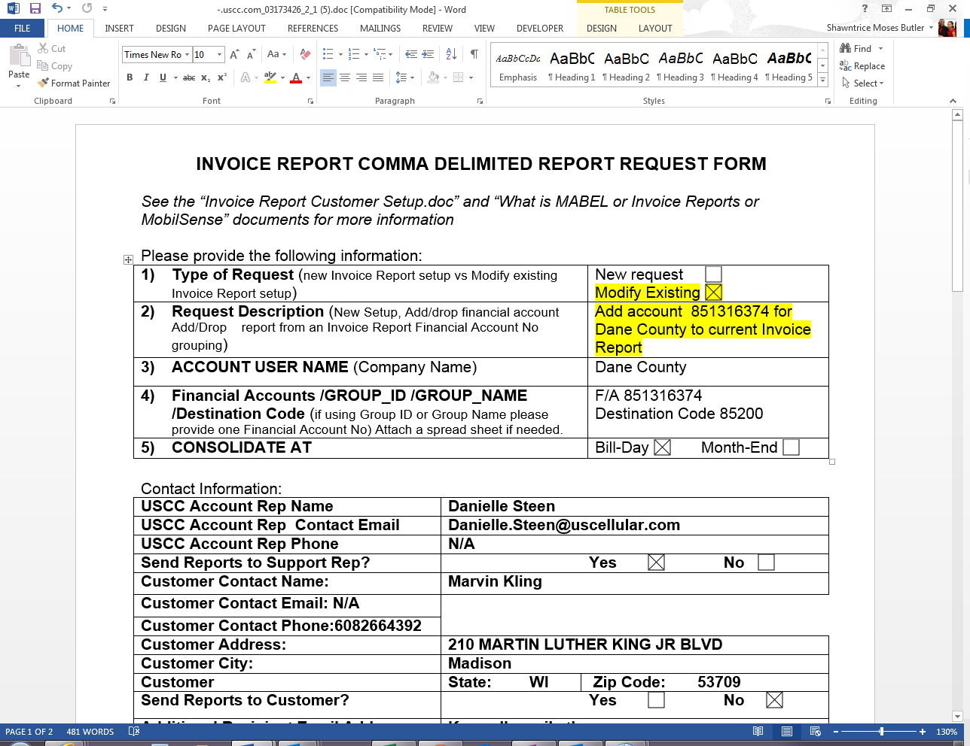

Query can be used to add FA to existing Invoice Report. Run in BODSPRD database.

*--Use this to create the inserts for the invrpt_acct_dest_link inserts by list of account_numbers*

*--It will ask for the INVRPT_DEST_CODE and EMPLOYEE_NO*

*--All accounts used must be going on the same INVRPT_DEST_CODE*

select 'insert into invrpt_acct_dest_link (BA_ACCOUNT_NO, INVRPT_DEST_CODE, EFF_DATE, SYS_CREATION_DATE, SYS_UPDATE_DATE, OPERATOR_ID, APPLICATION_ID, EXP_DATE, GROUP_ID) '

|| 'values (' || ba.ba_account_no || ', ' || &INVRPT_DEST_CODE || ' , to_date(01||to_char(ADD_MONTHS(sysdate,+1),''MON-YY''),''DDMON-YY''), sysdate, NULL, '

|| &EMPLOYEE_NO || ', ' || '''' || &EMPLOYEE_NO || ''',NULL,' || nvl(bgi.x_ban_group_id, 'NULL') || ');'

from table_x_ban_group_id bgi,

table_customer tc,

bl1_blng_arrangement ba

where ba.ba_account_no in (851316374)

and tc.x_customer2ban_group_id = bgi.objid(+)

and ba.ba_customer_no = tc.customer_id;

Example ticket: INC000001036058 / 03173426

**Patch:**

insert into invrpt_acct_dest_link

(BA_ACCOUNT_NO, INVRPT_DEST_CODE, EFF_DATE, SYS_CREATION_DATE, SYS_UPDATE_DATE, OPERATOR_ID, APPLICATION_ID, EXP_DATE, GROUP_ID)

values

(851316374, 85200 , to_date(01||to_char(ADD_MONTHS(sysdate,+1),'MON-YY'),'DDMON-YY'), sysdate, NULL, 924225, '924225',NULL,80029244);

**Request to Change Consolidation Date of Mabel and/or Mobilsense**

(Bill Date to End of Month or vice versa)

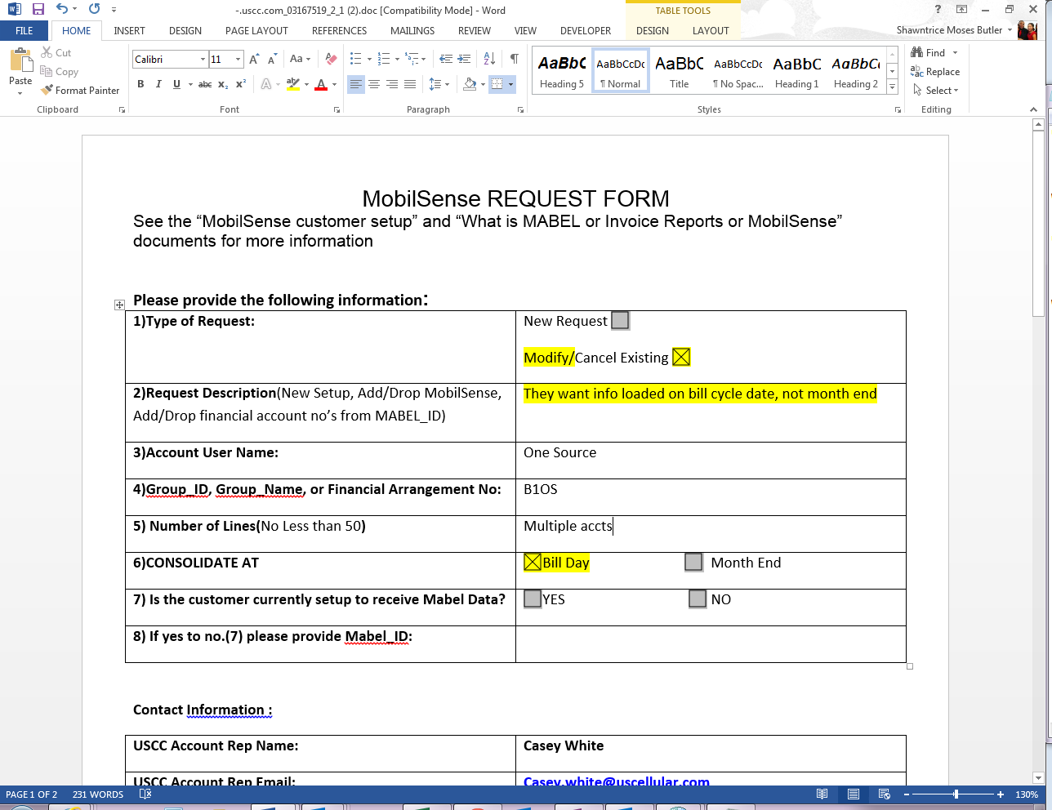

Run queries on ADD9_MABEL_IDS and MABEL_DESTINATION tables to ensure that the changes have not already been made.

select Consolidator, Consolidation_Period

from add9_mabel_ids

where consolidator = '90093'

select Consolidator, Bill_Method_Ind

from mabel_destination

where consolidator = '90093'

Example Ticket: INC000001021720 / 03167519

**Patch:**

update add9_mabel_ids

set CONSOLIDATION_PERIOD = 'EOC',

OPERATOR_ID = 924225,

APPLICATION_ID = 'MBL_ID',

EFFECTIVE_DATE = TO_DATE(01||TO_CHAR(ADD_MONTHS(SYSDATE,+1),'MON-YY'),'DDMON-YY'),

SYS_UPDATE_DATE = sysdate

where CONSOLIDATION_PERIOD = 'EOM'

and consolidator = '90093'

update mabel_destination

set BILL_METHOD_IND = 'B',

OPERATOR_ID = 924225,

APPLICATION_ID = 'MBL_ID',

EFFECTIVE_DATE = TO_DATE(01||TO_CHAR(ADD_MONTHS(SYSDATE,+1),'MON-YY'),'DDMON-YY'),

SYS_UPDATE_DATE = sysdate

where BILL_METHOD_IND = 'M'

and consolidator = '90093'

**Request to Cancel Invoice Report for all FAs**

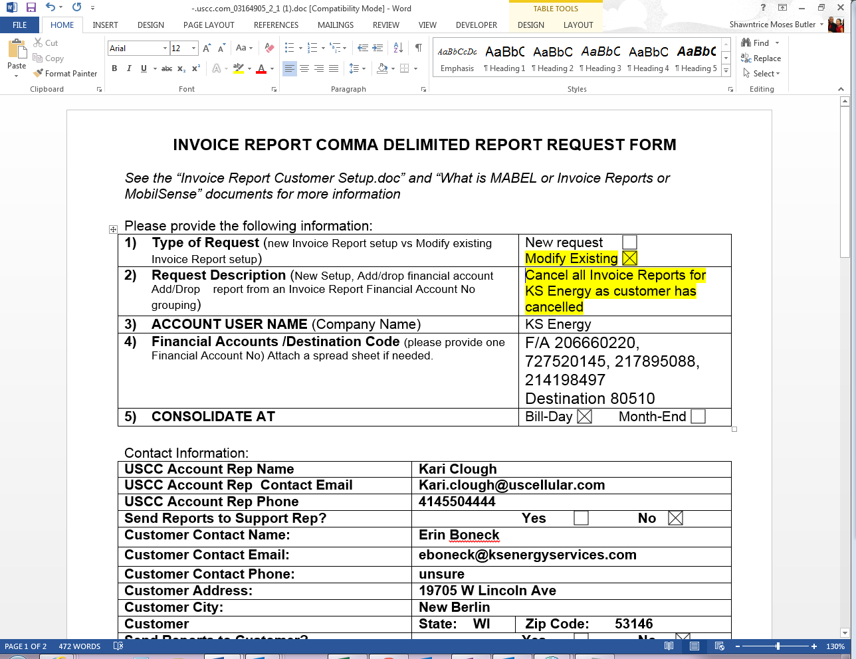

Example Ticket: INC000001015668 / 03164905

**Patch:**

update invrpt_destination

set EXP_DATE = last_day(sysdate),

SYS_UPDATE_DATE = sysdate,

OPERATOR_ID = 924225,

APPLICATION_ID = '924225'

where INVRPT_DEST_CODE in (80510);

update INVRPT_ACCT_DEST_LINK

set EXP_DATE = last_day(sysdate),

SYS_UPDATE_DATE = sysdate,

OPERATOR_ID = 924225,

APPLICATION_ID = '924225'

where INVRPT_DEST_CODE in (80510);

update INVRPT_REPORT_DESTINATION

set EXP_DATE = last_day(sysdate),

SYS_UPDATE_DATE = sysdate,

OPERATOR_ID = 924225,

APPLICATION_ID = '924225'

where INVRPT_DEST_CODE in (80510);

**Request to Add MABEL when the Customer already has MOBILSENSE**

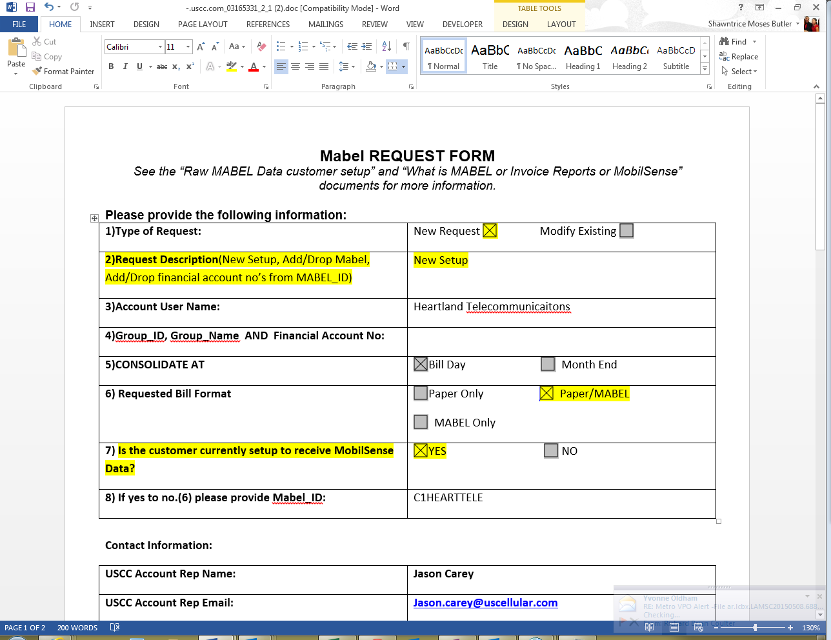

Run below query on ADD9_MABEL_IDS table to obtain the consolidator number.

select mabel_id, consolidator

from add9_mabel_ids

where mabel_id in ('C1HEARTTELE');

Output from query:

|  |  |
| --- | --- |
| **MABEL_ID** | **CONSOLIDATOR** |
| C1HEARTTELE | 90408 |

Use consolidator number to run below query on MABEL_DESTINATION table to confirm the current XMISSION_MEDIA_TYPE.

select Consolidator, xmission_media_type

from mabel_destination

where consolidator = '90408'

Output from query:

|  |  |
| --- | --- |
| **CONSOLIDATOR** | **XMISSION_MEDIA_TYPE** |
| 90408 | MBLS |

Example Ticket: INC000001016791/ 03165331

**Patch:**

update mabel_destination

set XMISSION_MEDIA_TYPE = 'BOTH',

OPERATOR_ID = 924225,

APPLICATION_ID = 'MBL_ID',

EFFECTIVE_DATE = TO_DATE(01||TO_CHAR(ADD_MONTHS(SYSDATE,+1),'MON-YY'),'DDMON-YY'),

SYS_UPDATE_DATE = sysdate

where XMISSION_MEDIA_TYPE = 'MBLS'

and consolidator = '90408'

**Request to Change Invoice Report_ID**

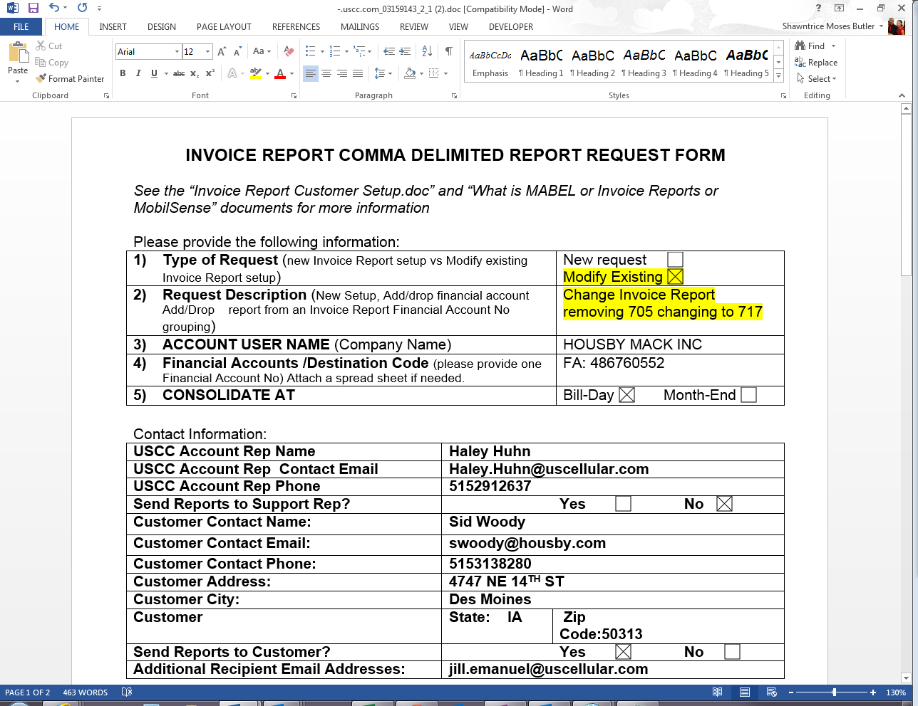

Example Ticket: INC000001001618 / 03159143

Since the Invoice Destination Code was not included in the request, run the below query on the INVRPT_DEST_LINK table using the FA provided to determine the code.

select ba_account_no, invrpt_dest_code

from invrpt_acct_dest_link_mv

where ba_account_no = '486760552'

Output from query:

|  |  |
| --- | --- |
| **BA_ACCOUNT_NO** | **INVRPT_DEST_CODE** |
| 486760552 | 75400 |

Use the Dest_Code to run the below query on the INVRPT_REPORT_DESTINATION_MV table to determine whether this task was already competed.

select invrpt_dest_code, report_id, exp_date

from invrpt_report_destination_mv

where invrpt_dest_code = '75400'

Output before patch:

|  |  |  |
| --- | --- | --- |
| **INVRPT_DEST_CODE** | **REPORT_ID** | **EXP_DATE** |
| 75400 | 705 |  |

Output after patch:

|  |  |  |
| --- | --- | --- |
| **INVRPT_DEST_CODE** | **REPORT_ID** | **EXP_DATE** |
| 75400 | 717 |  |
| 75400 | 705 | 7/31/2015 14:09 |

**Patch:**

update INVRPT_REPORT_DESTINATION

set EXP_DATE = last_day(sysdate),

SYS_UPDATE_DATE = sysdate,

OPERATOR_ID = 924225,

APPLICATION_ID = '924225'

where INVRPT_DEST_CODE in (75400) and REPORT_ID in (705);

insert into invrpt_report_destination

(REPORT_ID, INVRPT_DEST_CODE, EFF_DATE, SYS_CREATION_DATE, SYS_UPDATE_DATE, OPERATOR_ID, APPLICATION_ID, EXP_DATE)

Values ('717', 75400, to_date(01||to_char(ADD_MONTHS(sysdate,+1),'MON-YY'),'DDMON-YY'), sysdate, null, 924225, '924225', null);

**Request to Remove One FA from existing Invoice Reporting**

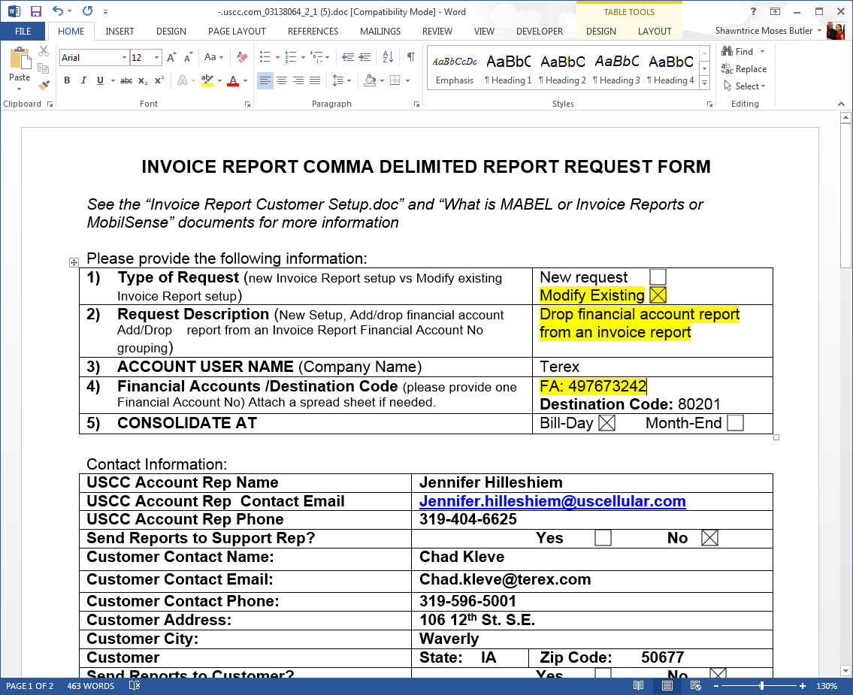

Run the below query on the INVRPT_ACCT_DEST_LINK table to determine how many FAs are currently reflected under this Dest_Code.

select * from invrpt_acct_dest_link_mv

where INVRPT_DEST_CODE = 80201

**If there are more than the one FA on the request use the below patch. If there is only one FA use the patch reflected under ‘Request to Cancel Invoice Report for All FAs’.

Example Ticket: INC000000952995 / 031318064

**Patch:**

update invrpt_acct_dest_link

set EXP_DATE = last_day(sysdate),

SYS_UPDATE_DATE = sysdate,

OPERATOR_ID = '924225',

APPLICATION_ID = 924225

where BA_ACCOUNT_NO in (497673242)

and INVRPT_DEST_CODE in (80201);